**SUKKUR IBA UNIVERSITY**

**TRANSPORT MANAGEMENT SYSTEM**

“YOUR COMFORT IS OUR PRIORITY”

**DATABASE MANAGEMENT SYSTEMS**

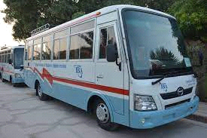

**SUBMITTED BY:**

Javeria Shahzad (023-21-0148)

Muhammad Talal (023-21-0094)

Mir Hussain (023-19-0106)

**SUBMITTED TO:**

Ma’am Faryal Shamsi

**TABLE OF CONTENTS**

|  |  |
| --- | --- |
| **TITLE** | **PAGE NO:** |
| **Problem Statement** | **PAGE NO: 03** |
| **Solution to the Problem** | **PAGE NO: 04-06** |
| **Roles of group partners** | **PAGE NO: 10** |

**PROBLEM STATEMENT:**

Sukkur IBA University is a popular higher education institution in the city of Sukkur, Pakistan. With the increasing number of students enrolled in the university, the demand for reliable transportation services has also grown. The university currently operates several buses to transport students and staff to and from the campus. However, the existing transportation system is struggling to meet the demand, and there are often long queues and delays, which leads to frustration among students and staff. The current transportation system is not efficient, most of the students’ waste their time in waiting for seats, bus arriving time, departure time and it has become difficult for the transport department to manage the transportation of students and staff. The existing system relies on manual processes, which are time-consuming and prone to errors. Therefore, we have decided to develop a SIBAU Transport Management System that will allow students and staff to book their seats in advance, view each bus destination, arrival time, departure time and manage their time accordingly.

**PROPOSED SOLUTION:**

The proposed SIBAU Transport Management System will develop by using Java and MySQL. The system will provide a friendly interface for students and staff to book their seats, with priority based app access, view booked seats & select their departure time accordingly. The system will have the following features:

**Admin:**

The system will allow the admin to manage the entire transportation system, including managing the bus routes, schedules, and drivers.

**User:**

Students and staff will be able to register/sign up for the transportation service and provide their details, including their names, passwords etc.

**Destination:**

Students and staff will be able to Book their seat on the time according to their destination.

**Bus Information:**

The system will tell the bus information provided to the students and staff about the expected arrival time and departure. This will allow students and staff to manage their time more efficiently and avoid delays.

**Booking:**

Once registered, students and staff will be able to book their seats in advance, based on their preferred route and availability of seats. The system will allocate seats automatically.

The SIBAU Transport Management System will be a comprehensive solution that will streamline the transportation system's management, improve the transportation service's quality, and reduce the burden on the university administration. The system will also ensure the safety and security of the students and staff during their transportation to and from the university. By implementing the proposed system, the university administration will be able to provide an efficient and reliable transportation service to its students and staff.

**THIS PROJECT INCLUDES THESE TABLES:**

|  |  |
| --- | --- |
| Entities | Attributes |
| ADMIN | Admin_id  PASSWORD |
| USER | User_id  Name  PASSWORD  IsBooked |
| Points | P_ID  CAPACITY  BOOKED_SEATS  AVAILABLE_SEATS  Origin  Destinations  A_TIME  D_TIME |

**ER Diagram:**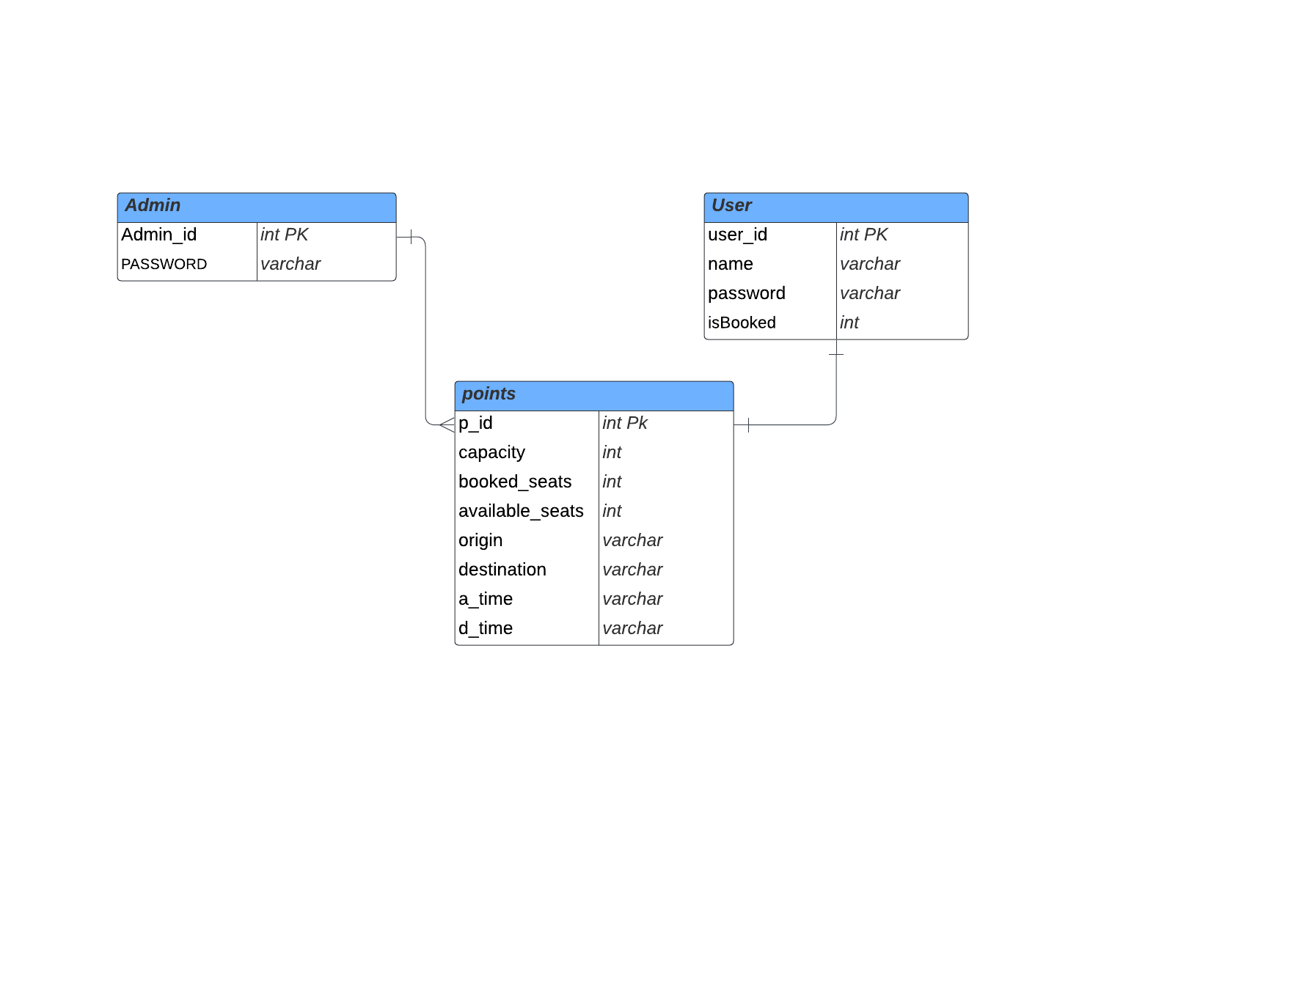

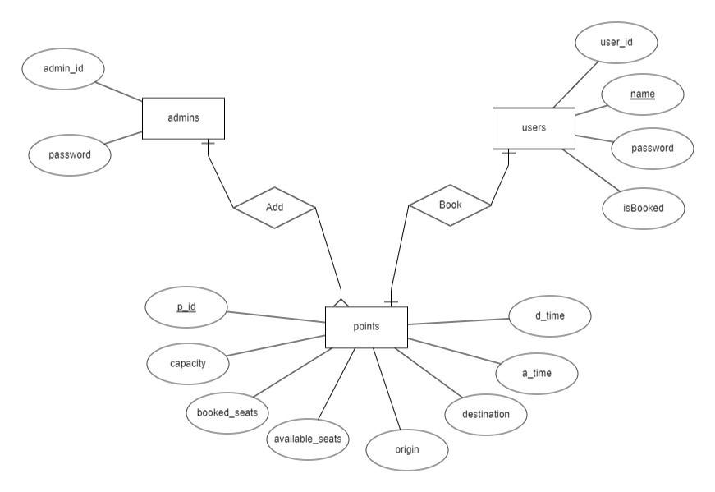

**Conclusion:**

In our project Sukkur IBA Transport Management System, we will store all the information about the arrival time, bus destination, departure time. This database is helpful for the applications which facilitate students as well as faculty too. They can book the ticket and check the details of buses. The system will be online and time saving.

**ROLES OF TEAM MEMBERS:**

|  |  |
| --- | --- |
| Name: | Roles/Description: |
| Javeria Shahzad | OUR WHOLE GROUP WILL TOGETHER WORK ON ALL ASPECTS OF PROJECT INCLUDING DATABASE MANAGEMENT USING MY SQL & GRAPHICAL USER INTERFACE USING JAVA SWINGS. |
| Muhammad Talal |
| Mir Hussain |